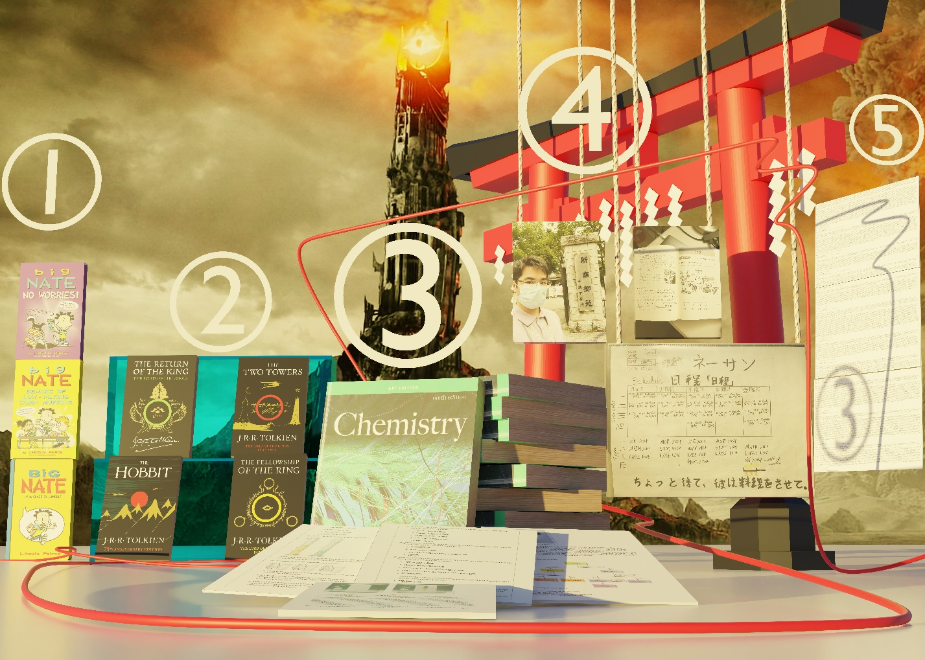
Please go to this link to view and scroll around this image. I rendered out a 140 000 000-pixel image in Blender so you can look at even the small text on the right side of the image clearly. In order to share it I had my father upload it to a webserver. When viewing image: Let the entire image load and a magnifying icon appear as your mouse before clicking and dragging, doing so in the beginning may cause the webpage to disconnect or cause a big lag spike.
https://talks.fikesfarm.com/nathan/english-assignment.png
https://talks.fikesfarm.com/nathan/english-assignment.jpg (Loads much faster)
Blender work on the scene below.
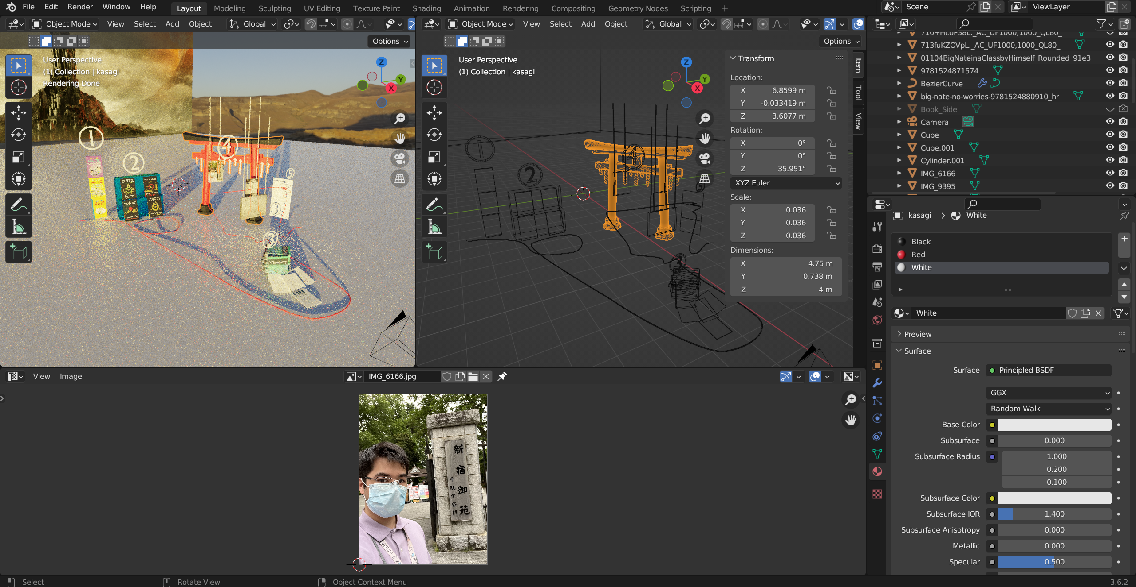
Section 1:
Description: Three BIG NATE books by Lincoln Peirce stacked on top of each other. The top two are covers from more recent years with the Paramount Nickelodeon series and the bottom being an older cover. I read these books in middle school so the bottom cover is more familiar.
Literary Significance: These were the first books I was introduced to while in middle school. Truthfully, I didn’t like reading that much as a kid, so these books had a slightly different structure than other books like “I Survived” or “Warrior Cats.” These books were more like “Diary of a Wimpy Kid” or “Captain Underpants.” This series features a comic style writing system with lots of black and white visuals with only text for dialogue. There were secret codes and little interactive pages within the hardcover which engaged the reader. The art style on these books were also commonly depicted on top of loose-leaf paper. What made this book so influential was not because I shared the same name as the main character, but because the books were about a character going through school. I felt a direct connection (other than bad grades maybe) with Nate in these books which compelled me to read them. Connection with the protagonist on a personal level is what allowed me to experience the book in a more exciting way. Eventually this led to me branching out to find characters I can look up to instead of identify with.

Section 2:
Description: Four Lord of the Rings books by J.R.R. Tolkien “The Hobbit”, “The Fellowship of The Ring”, “The Two Towers”, and “The Return of The King” are resting on a blue glass platform. This is the entire series of the Lord of the Rings. The Hobbit is the first section, and the three other books are section 2 post Bilbo. I read this series a couple of times during high school as well as watched the films a couple times.
Literary Significance: This was my favorite series much more than “Harry Potter” or “Maze Runner” because of how descriptive the books were and how dynamic each scene was. I was so enthralled by the series that I reread them again after watching the films. This was my first-time rereading for pleasure but also to find details I may have missed the first time. This series has so many dynamic and unique characters that come from exclusive origins that each new adventure is thrilling. This series also kick started my love for fantasy novels like “The Letter to The King.” Not only were the books good but the film reinforced my love for the series. Books are meant to be interpreted in any way imagined. The movies for this series exactly matched my imagination for the books which gave me the confidence to tackle more books. This was also a good lesson in retrospect thinking where I go back and reevaluate my initial perspective. Overall, this was a good leap in my literary experience and has shaped the way I write and think.

Section 3:
Description: A familiar sight to see in a high school laboratory; a ton of Chemistry textbooks stacked up near the wall. This is one version of a Chemistry textbook as a stand-in for the one I used in AP chemistry (I forgot the actual title). My teacher assigned lots of writing assignments that involved reading these textbooks. Several papers of a typical high school Chemistry textbook are laid out in front of the stack in the image.
Literary Significance: These were usually dense, information heavy, and sometimes confusing books. Though there is one fundamental thing in the way they are structured that makes them powerful. They are assembled systematically. Every chapter had a way in which it was constructed: preface, topic, equations, explanations, demonstrations, and applications. All chapters were written in this way. Back in high school, I wrote around 25-30 pages over 14 chapters of this book by employing an outline strategy that worked every time. Because of this, I was able to absorb and retain key concepts from text that would normally take a couple of days to read. I was able to read while expecting certain words or phrases (predictive reading) which allowed me to quickly move within the text, but retain the content. In addition to reading these books, I found that writing the outlines helped me format my own writing to be descriptive and legible. My teacher also did an excellent job pointing out what things are important, and which are not. This sped up the efficiency at which I read large texts and has allowed me in the present day to read my own large texts.
Section 4:
Description: A Shoji gate with hanging Shimenawa with pictures from: Japan, Japanese language study, and Japanese language integration into my life. The left most picture under section 4 is me standing next to the 新宿御苑 千駄ヶ谷門 (Shinjukugyoen sendagaya mon) which means Shinjuku Imperial Garden Sendagaya Gate. This was during a Study Abroad internship. The upper right Image is work in the 基本漢字 (Kihonkanji) which means Basic Kanji. This is in a book where I worked on reading exercises in Japanese and write responses in Japanese. The third image under section 4 is my integration of the Japanese language into my own daily experiences to make sure I’m constantly exposed to the language.
Literary Significance: Even though Japanese is a completely different language with one of the scariest writing systems, it still helps me understand the nuances of the English language. In addition, writing in Japanese involves me having to really understand English sentences before I convert them. Japanese translation tasks me to pick apart the sentence by common forms you may have learned in school such as subjects, verbs, nouns, adjectives, plurality, past tense, present tense, passive form, etc. In a sense, learning Japanese is teaching me more about English because I’m commonly working with linguistic structures. The more I advance in Japanese writing and reading the more I must dive into more complex English sentence construction. With this backward sentence structure, I need to first identify the parts of an English sentence correctly, and then assemble them in a way that a foreign person would understand. This is an interesting way to improve my own literacy skills.

Section 5:
Description: These are 3 segments of my journals which each contain a couple days’ worth of observations while on the Study Abroad trip. It is placed after because it is still a current event, and it still helps me remember things.
Literary Significance: These journals are written every day and consist of observations I make about those days. These are descriptive and informational writing pieces that are quite significant in size. The main reason these are important is because they allow me an outlet to practice writing. They also help me remember better. Whenever I take classes, I’m always taking notes of what I currently hear from the teacher or read on the board. Writing journal entries allow me the freedom to write after the event happens. The ability to absorb from reading, hearing, and seeing and then descriptively write them down in journal format helps my writing gain clarity and readability. I can retroactively see how I’ve been progressing over the years, evaluate what needs to be changed, and generate improvements in the form of new journals. Overall, this is a great strategy to keep my reading and writing skills strong as well as improve my ability to retain information after absorption. Journals give me the flexibility to describe things around me and allow me to be creative with how I write.

